**Descripció de l’activitat**

Al present document pots trobar un seguit de tasques a resoldre individualment. Procura ser tu qui les faça completament, amb la menor ajuda possible de companys, però consultant totes les fonts necessàries a internet o altres mitjans, i raonant com es resolen.

Es recomana l’ús de **SelectorsHub** o **ChroPath** per la selecció de les parts de codi indicades.

### *Task to do:*

### 

From the index web document that you will find in the URL ([Novel Updates](https://www.novelupdates.com/)) accessing through the internet, answer the following questions correctly listed:

| **1.-** Select **ALL the links in the webpage** that appears on the main page.  *Hint: on 15/03/21 there are 301 different links.* |
| --- |

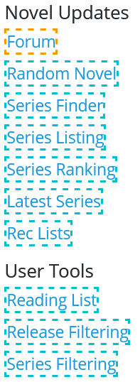

|  |
| --- |

| **2.-** Find an xPath to select every link in the **Novel Updates section**  and the **User Tools section**.  *Hint: Try to select first only one section, and later the other section* |
| --- |

|  |
| --- |

| **3.-** Find an XPath that selects **the link elements** under the Latest Topics.  Hint: You may use the words ‘Latest Topics’ in your xPath |
| --- |

|  |
| --- |

| **4.-** Select **only the arrow icon** close to the login icon. *Hint: check the @class attribute.* |
| --- |

|  |
| --- |

| **5.-** Select **only the last tree webpage elements**.  *Hint: check the attributes.* |
| --- |

From **this new webpage** you will find in the URL (<https://spaceplace.nasa.gov/en/>), answer these questions:

| **1.-** **Select all the section items** from the main page. |
| --- |

|  |
| --- |

| **2.-** Select the **link element** to change the webpage language. You cannot use the text inside the element. |
| --- |

|  |
| --- |

| **3.-** Find an xPath that selects the **footer elements** of the webpage. |
| --- |

|  |
| --- |

| **4.-** Find an xPath that **selects all the images element** in the February art Challenge section (44 images). |
| --- |

Now, from **this new webpage** you will find in the URL (<https://spaceplace.nasa.gov/menu/science-and-technology/>), answer these questions:

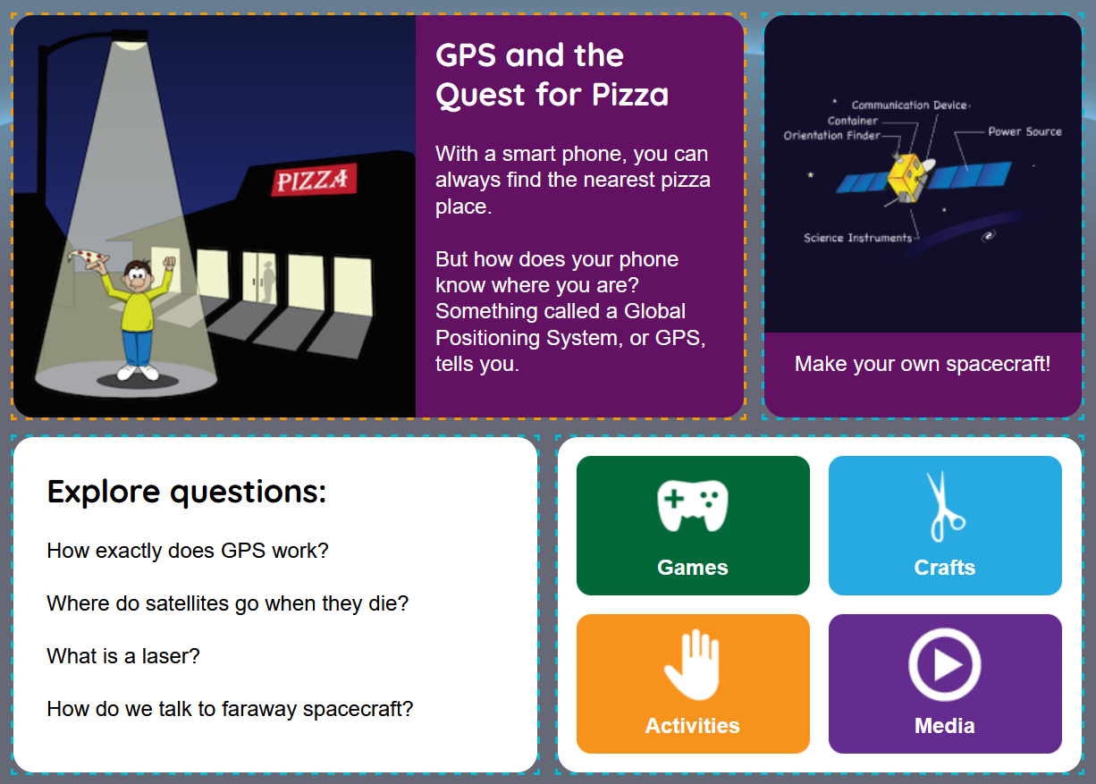

| **1.-** Find an xPath that selects from the Science and Technology menu, **the four main sections elements**. |
| --- |

|  |
| --- |

| **2.-** Now find an xPath that **selects all these six items**: |
| --- |

|  |
| --- |

| **3.-** Now try to select **only all the elements below** the previous items: |
| --- |

|  |
| --- |

| **4.-** Select the **last element** in the webpage, from the previous selection: |
| --- |

|  |
| --- |

| **5.-** Select the **elements with** the **NASA word** inside. |
| --- |

|  |
| --- |